6).Create a simple cloud software application for Payroll Processing System using any Cloud Service Provider to demonstrate SaaS include the necessary fields such as Name of the employee, experience in present org , over all experience, basic pay, HRA, DA, TA, net pay, gross pay etc

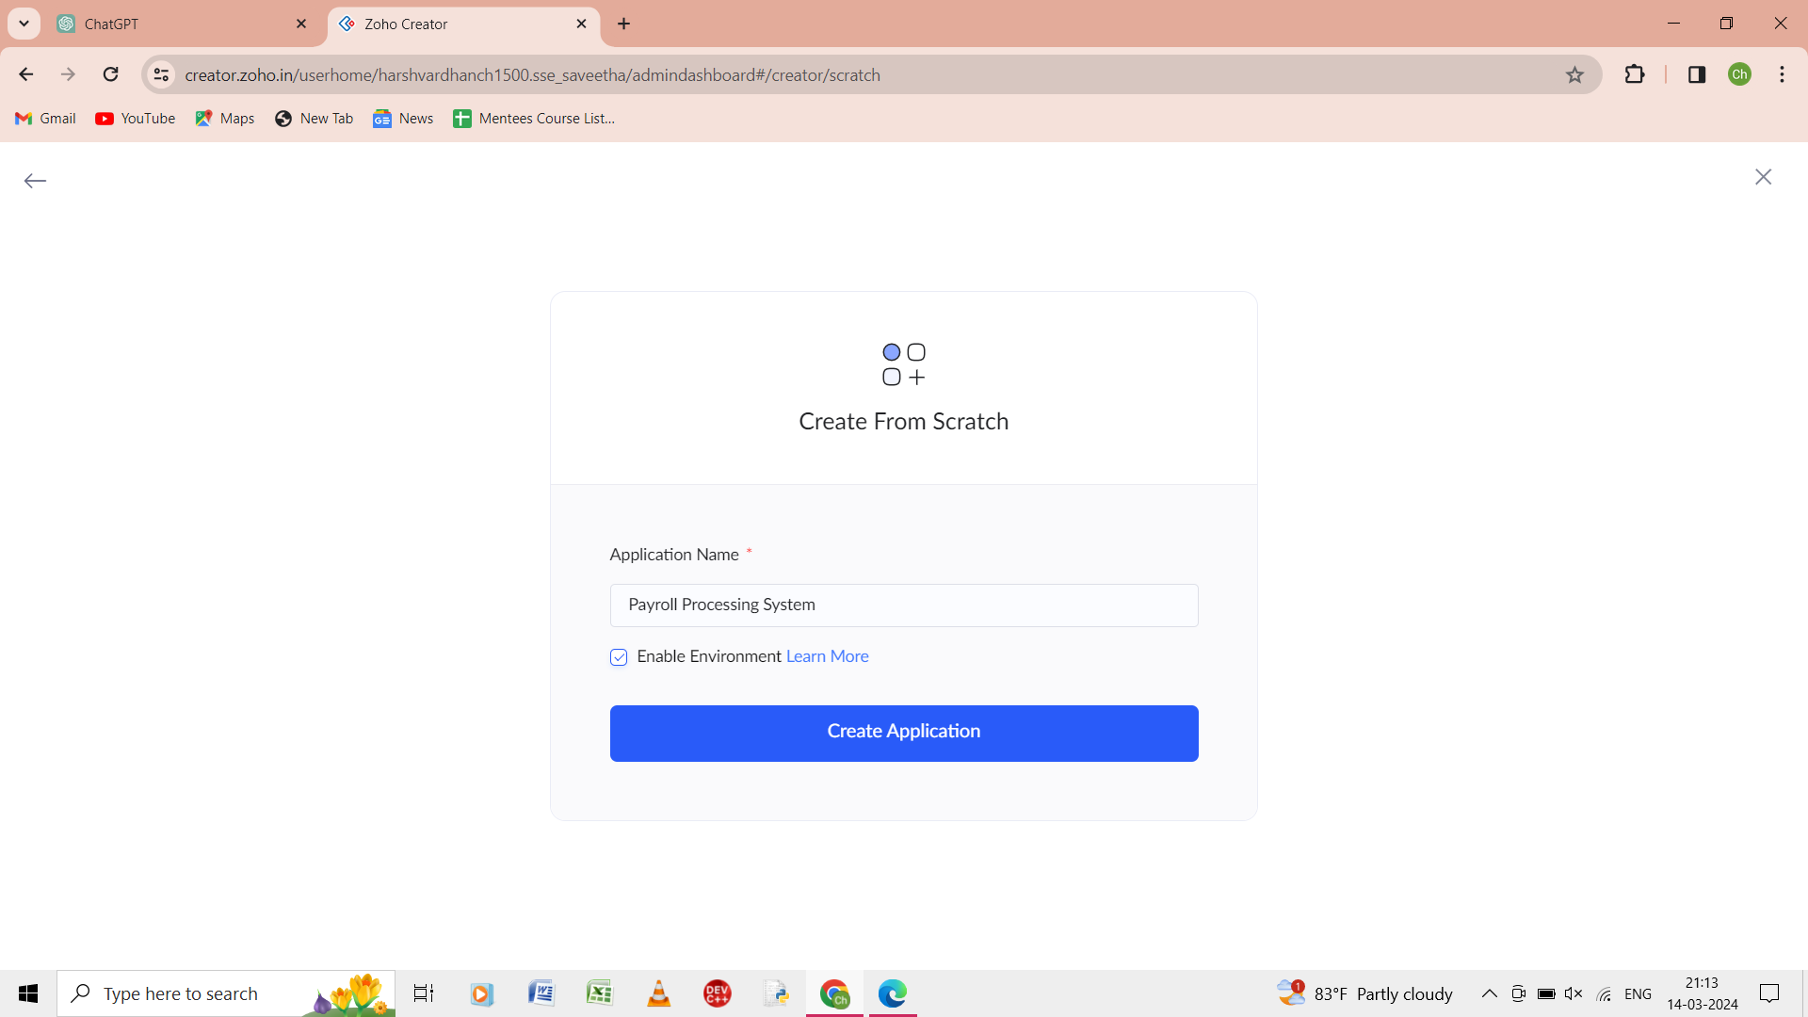

Step 1: from the scratch give the application name as payroll processing system.

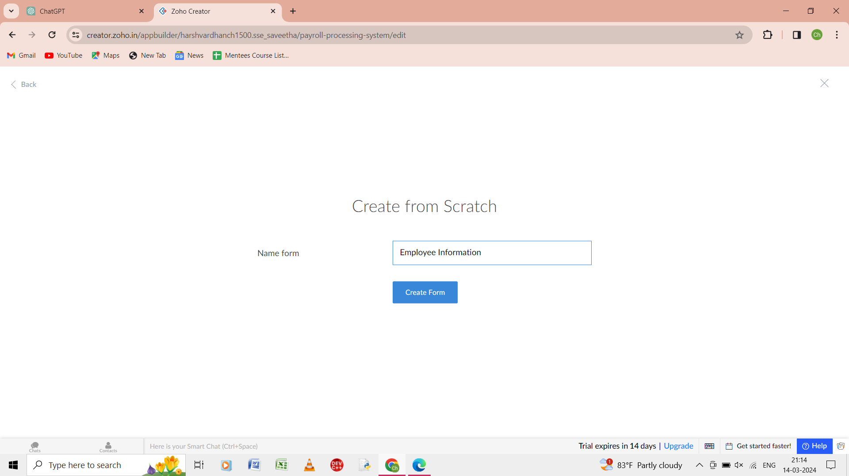

Step 2: from the scratch give name of the form as employee information.

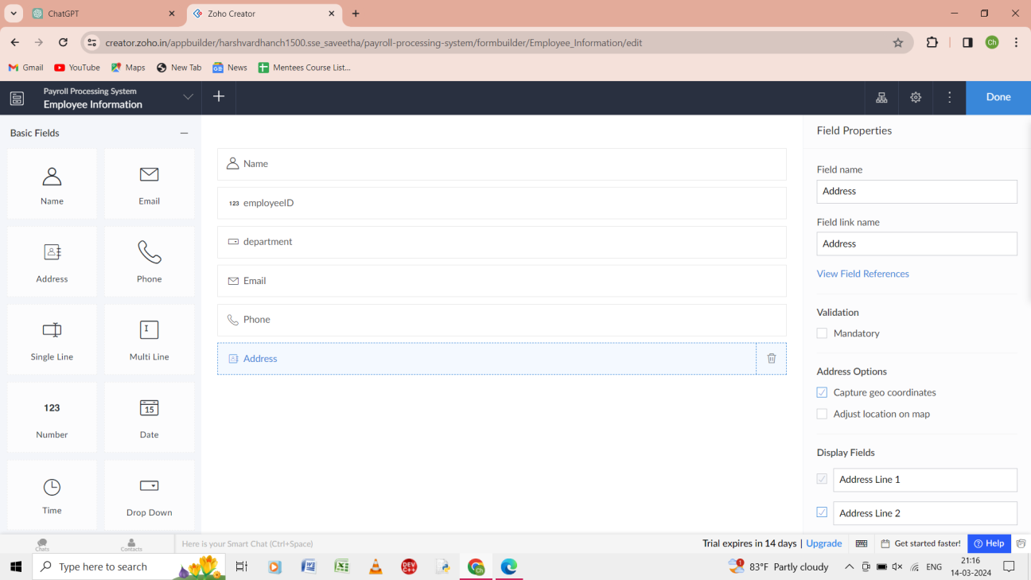

Step 3: In the form of employee information enter the name, employee ID, department , email, phone, address.

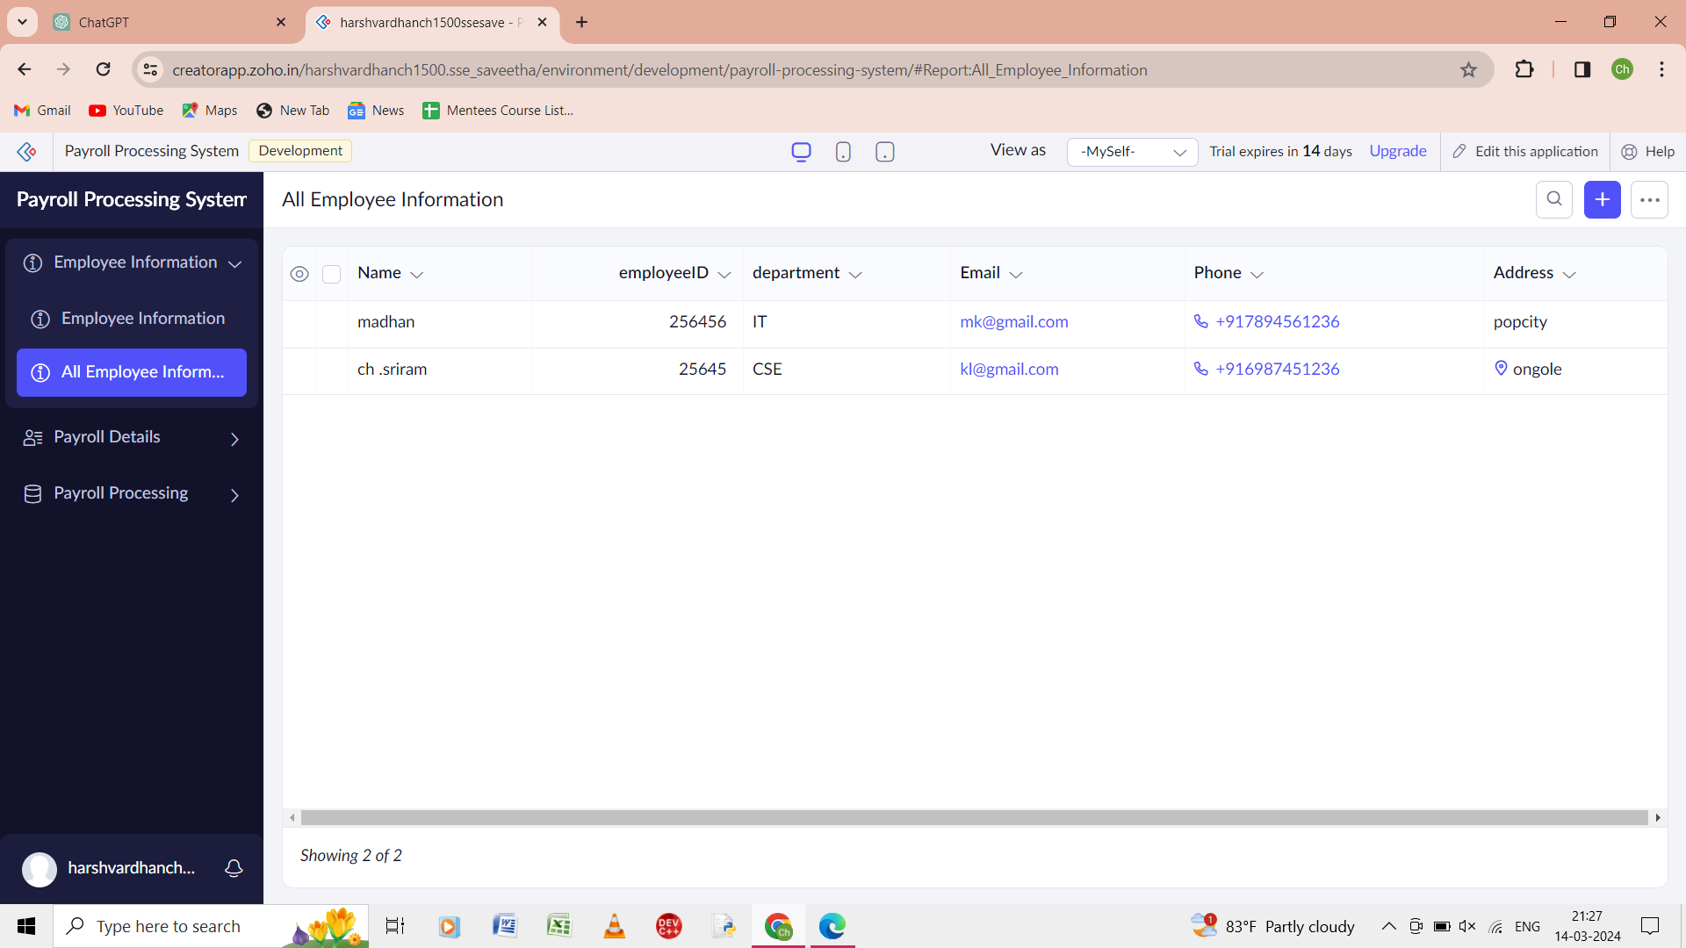

Step 4: the details of employee information is given in the report of the employee information.

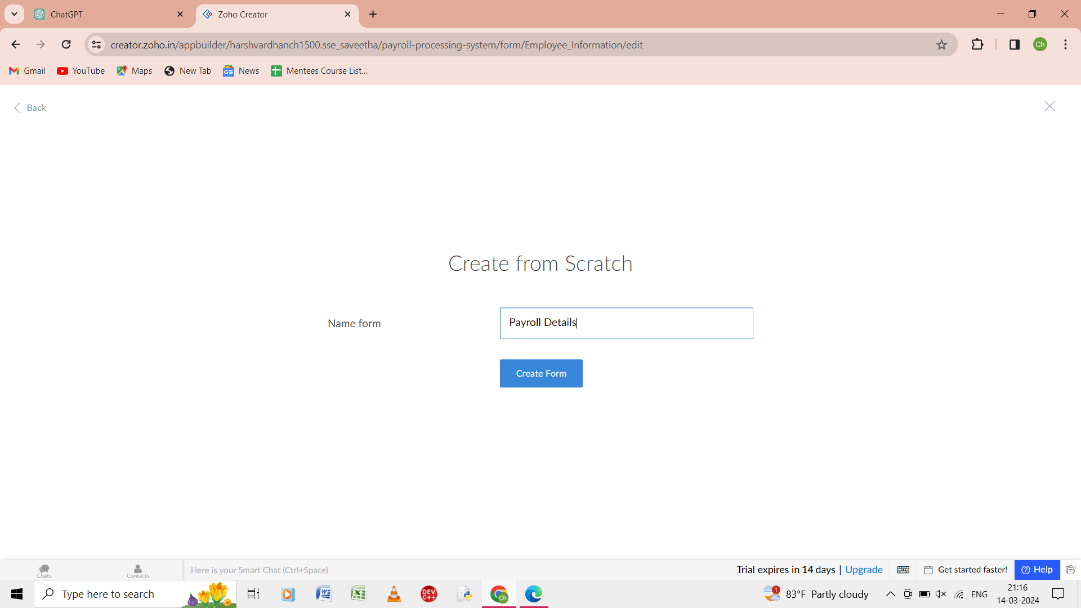

Step 5: from the scratch give the name of the form as payroll details.

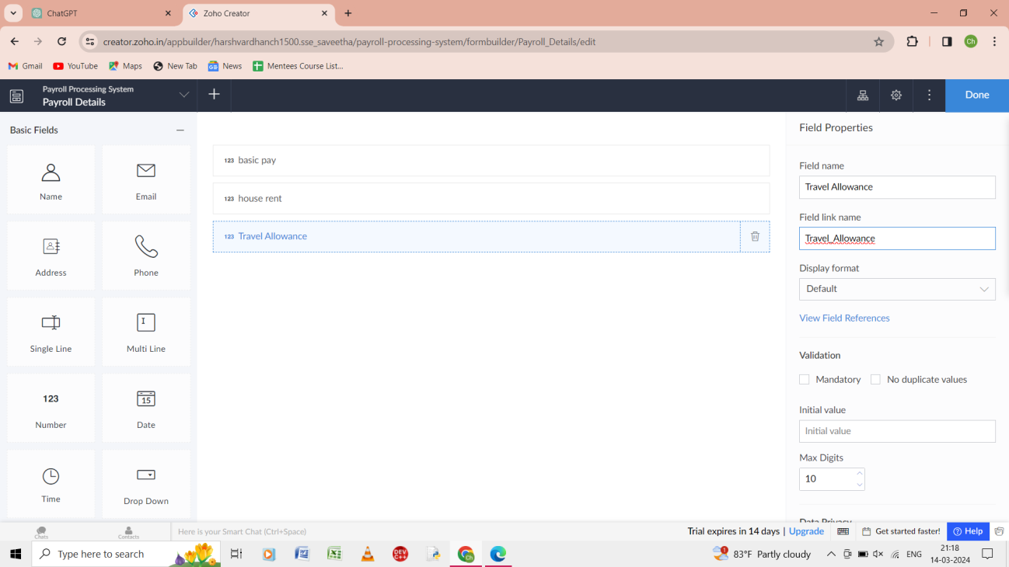

Step 6: In the form of payro;; details enter the basic pay, house rent, travel allowance.

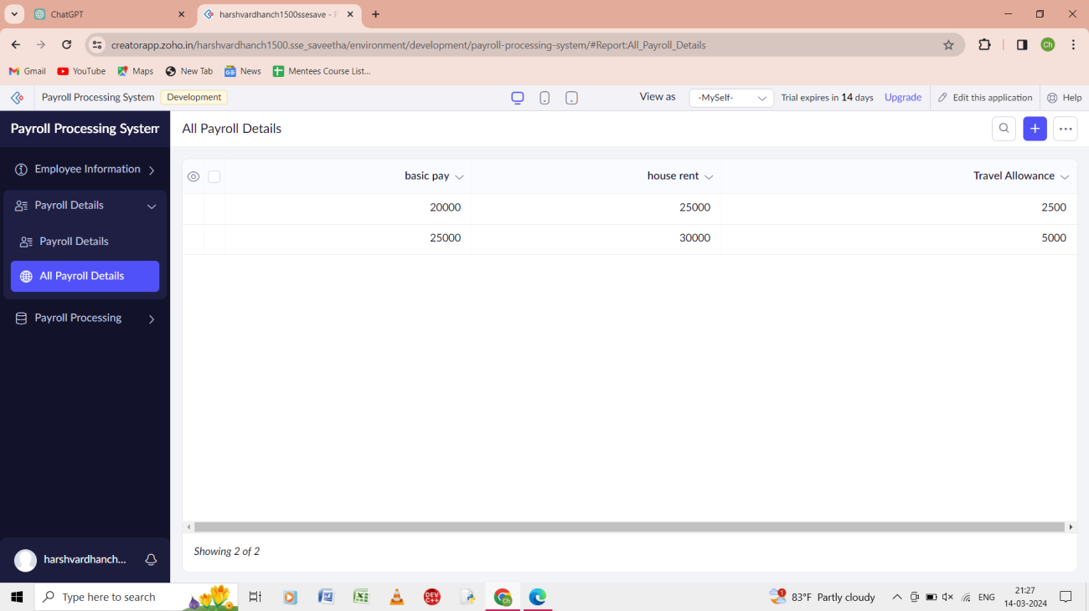

Step 7: In the payroll details form give input as the following.

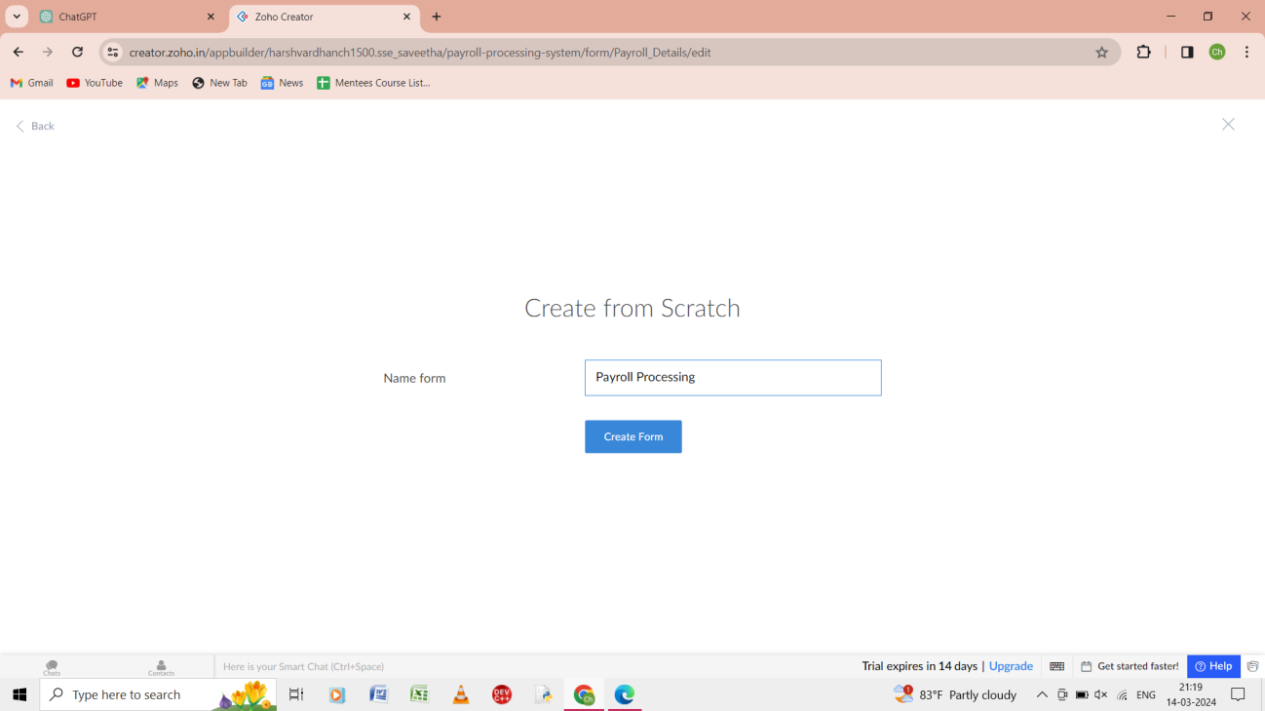

Step 8: from the scratch give the name of the form as payroll processing.

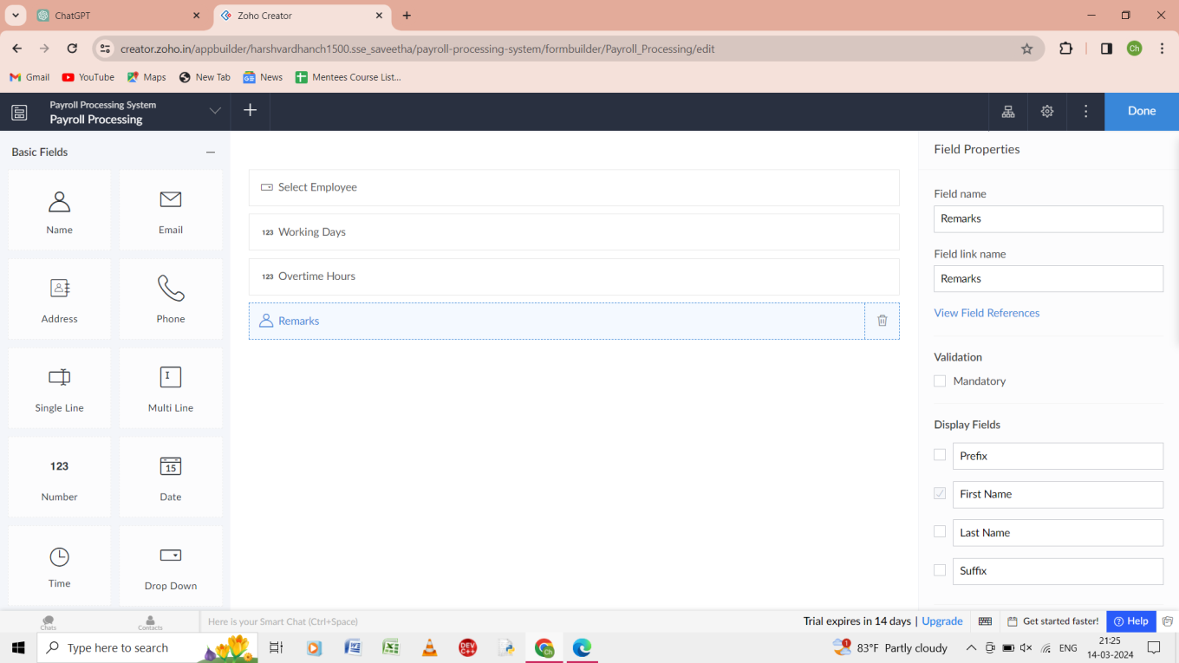

Step 9: in the payroll processing of the form give the input as select employee, working days, overtime hours, remarks.

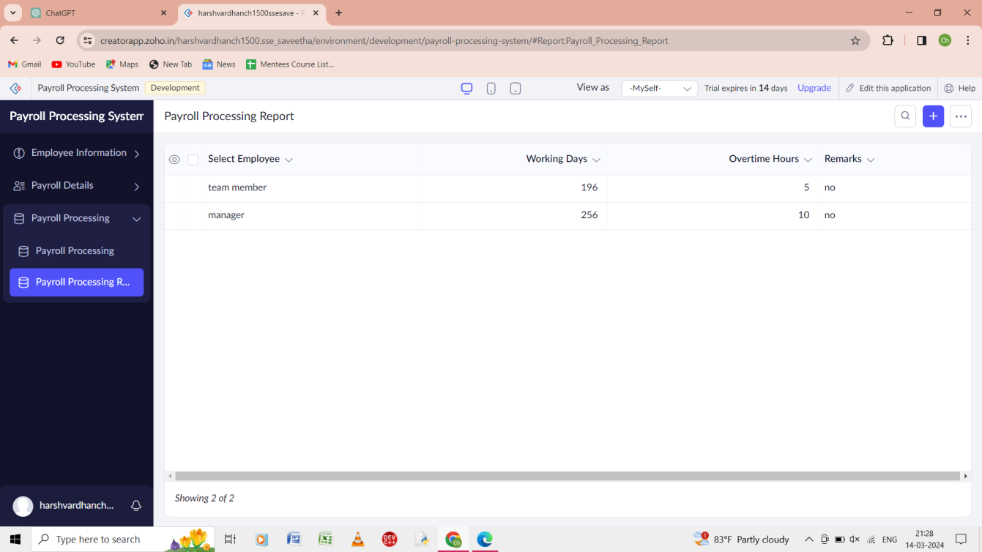

Step 10: the payroll processing of the form of the report is shown.